**Pickup a package: Use case description**

The following is a breakdown of the use case Pickup a package that describes the process of a driver picking up a delivery with multiple possible steps based on package and delivery request information:

|  |  |  |
| --- | --- | --- |
| Use case name: | Pickup a package. | |
| Scenario: | The delivery employee picks up a package. | |
| Triggering event: | The delivery employee travels to the customer’s pickup location and picks up the package. | |
| Brief description: | Upon arriving at a pickup location, the driver pulls up and verifies the package information is correct and entered into the system. The driver can also change address and delete or add new packages. The driver may print mailing labels and transaction receipts at the customer destination with a portable printer. If the payment is in cash it is collected and processed. | |
| Actors: | Delivery employee | |
| Related use cases: | Request a package pickup. | |
| Stakeholders: | Customer, Employee. | |
| Preconditions: | The customer must have an account on the company website.  The customer must place a pickup request. | |
| Postconditions: | The package(s) is/are picked up from the customer. | |

|  |  |  |
| --- | --- | --- |
| Flow of activities: | Actor | System |
|  | 1. Access customer account and  delivery requests.  2. Validate package  information.  3. If applicable, enter new  packages, delete packages, or  change delivery address.  4. If the customer pays in cash,  payment is collected and  recorded.  5. A receipt is printed for the  customer as necessary.  6. Mailing label(s) is/are  printed for any new packages  added to the delivery request  or packages without labels. | 3.1 Customer delivery request is  updated with new  information.  4.1 Payment is recorded in  customer account.  5.1 Receipt is created and  printed out.  6.1 Mailing label(s) is/are  created and printed out for  new packages or packages  missing labels. |
| Exception conditions: | 1. Customer account cannot be accessed; package information  must be validated by customer.  3.1 Account fails to update with new information; updated  information must be manually recorded and entered later.  4.1 Payment is unable to be recorded; record of payment is  manually recorded.  5.1 Receipt fails to print.  6.1 Mailing label fails to be created/printed. | |

**Pickup a package: Activity Diagram**

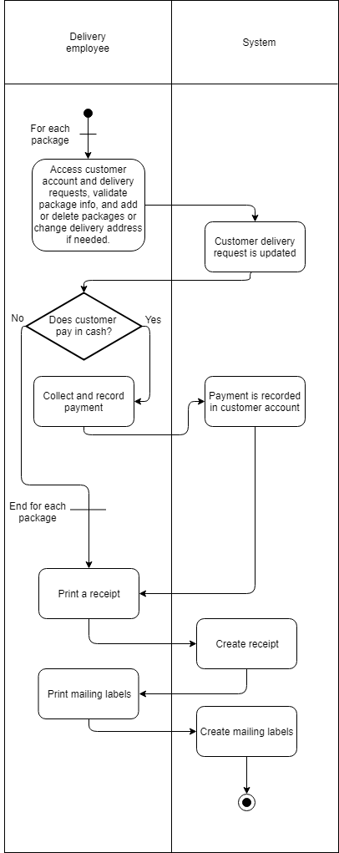

**Pickup a package: System Sequence Diagram**

